Kolavo User Testing
Saturday, July 18 2026
No. | What happened? | How should it be? | Checking
1 | - When admin reviewing incoming applicants, the modal shows both FullName.  - Trying again shows FullName both in List of applicants and applicant modal:  - 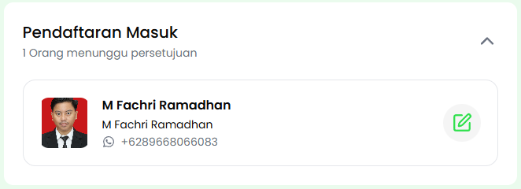  - 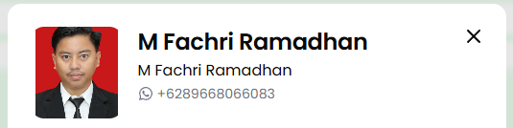 | Showing FullName and NickName. | - In community and in profiles, they correctly show NickName  - 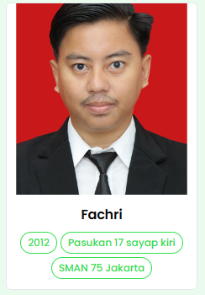  - 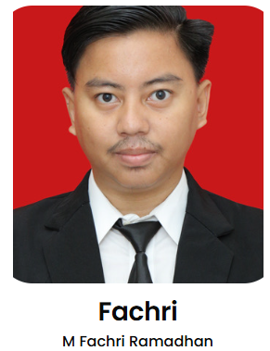
2 | Member ID should not be a chip as it is an identification just like name  - 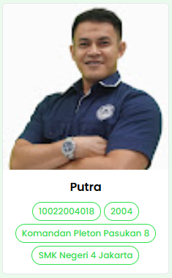  - 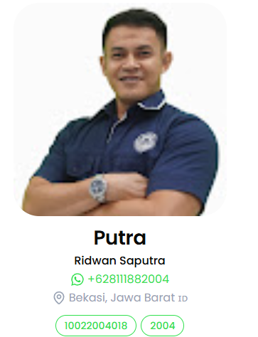  - 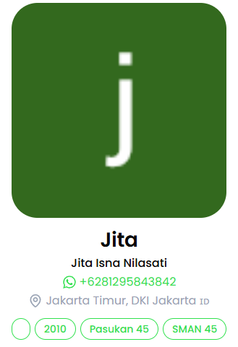 | Just like name, Member ID could be put under nick name and only shown when admin look member profile from a community.
3 | User could not edit their input leads to wrong data  - 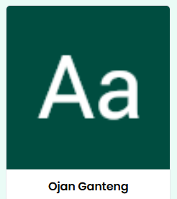  - 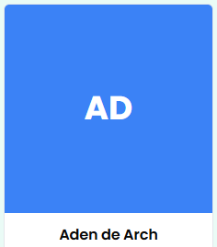 | Correct answer based on community should be:  - Ikapunija  - Ojan  - Argi  New flow is needed | - Their wrong input affect their profile credential  - 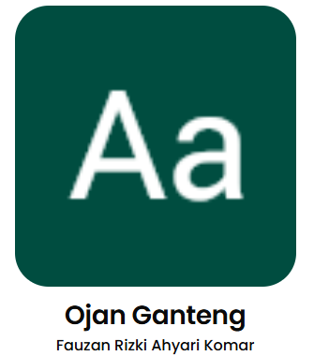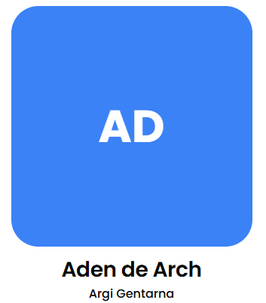
4 | - User forgot their membership  - 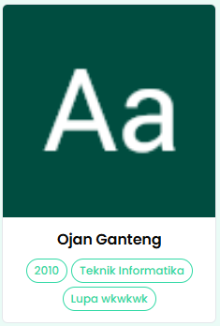  - 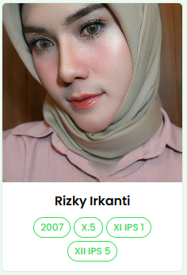 | Correct answer based on community should be:  - IKAPUNIJA  - IT AeU  - IKAMADU  - XI IPS 5  - XII IPS 1  Answers from other users could become a recommendation dropdown list since they are within the same community.  New flow is needed
5 | - Did not read the question properly lead to wrong input  - 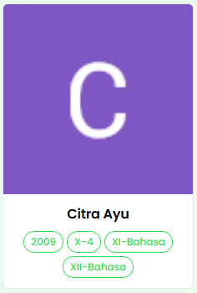  - 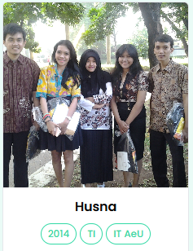 | Their based on community answer should be  - IKAMADU  - 2006  - IKAPUNIJA  - 2010
6 | Use different format of answers  - 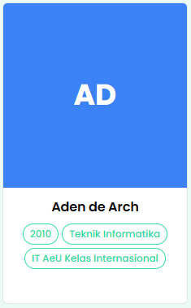  - 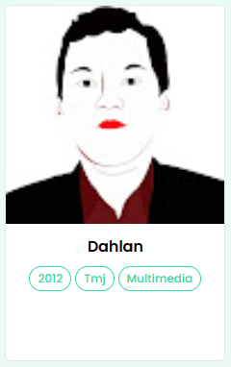  - 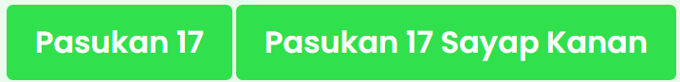  - 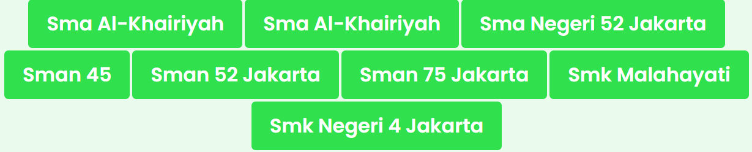 | Their answers based on community should be:  - IKAPUNIJA  - IT AeU  - Teknik Multimedia & Jaringan  - PPIJU  - Pasukan 17  - SMAN 52  - SMAN 45  - SMAN 75  - SMK Malahayati  - SMKN 4
7 | These two are exactly the same but show separately, making the member distribution did not describe its member  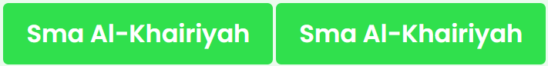 | Only one chip containing 2 members
8 | Chips shown in community page was not limited  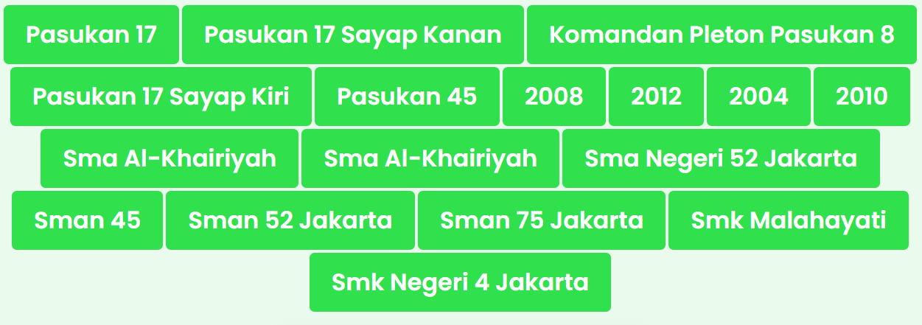 | Show maximum 15 only
9 | Photo uploaded from users are blurred  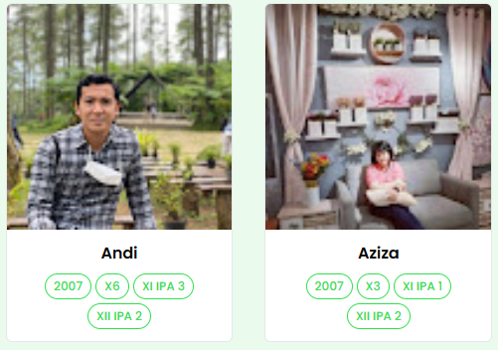 | Not blurred
10 | Photo uploaded from user is cut  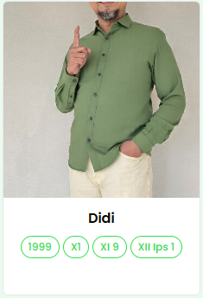 | Show face properly
11

